DATA SCIENCE FUNDAMENTALS
ASSESSMENT
Task 1 – Data Analyst Internship
Student Name: Sonu Kumar
Internship/Program: Yuva Intern
Submission Date: 08/10/2026

1. Introduction to Data Science
Data Science is a multidisciplinary field that brings together programming, statistics, mathematics, visualization, and subject knowledge to draw useful insights from data. Its goal is to turn raw, unorganized data into clear findings that help people make better business and analytical decisions.
A typical Data Science project moves through several stages: defining the problem, collecting data, preparing it, exploring it, building models or running analysis, evaluating the results, sharing the findings, and deploying or monitoring the solution when needed.

1.1 Data Science Lifecycle
- Define the problem: state the business or analytical question that needs to be answered.
- Collect data: gather relevant data from dependable sources such as databases, files, surveys, or APIs.
- Clean and prepare data: fix missing values, remove duplicates, correct formats, and make records consistent.
- Explore the data: study distributions, trends, relationships, and unusual patterns.
- Analyze or model: choose suitable statistical or analytical techniques for the question.
- Evaluate results: confirm that the findings are reliable and actually answer the objective.
- Communicate insights: present findings through reports, tables, charts, and plain-language explanations.
- Act and monitor: use the insights in decisions and keep tracking the results over time.

1.2 Common Applications
- Customer behaviour and sales analysis
- Fraud and anomaly detection
- Customer segmentation and targeted marketing
- Supply chain and logistics optimization
- Demand and sales forecasting
- Healthcare and scientific research
- Personalized recommendation systems for products and content

2. Python Basics for Data Science
Python is popular in Data Science because its syntax is easy to read and it offers a rich collection of libraries for data handling, statistics, visualization, and machine learning.

2.1 Variables and Data Types
A variable is a named container that holds a value. Python identifies the data type automatically from the value you assign, so no separate type declaration is needed.
Example:
student_name = "Riya Sharma"
attendance = 87
fee_paid = 12500.75
is_enrolled = True

2.2 Main Built-in Data Types
Data Type | Example | Use
int | 42 | Whole numbers (no decimals)
float | 3.14 | Numbers with decimals
str | "Pandas" | Text
bool | False | True / False values
list | [5, 15, 25] | Ordered, changeable collection
tuple | (1, 2, 3) | Ordered, unchangeable collection
set | {2, 4, 6} | Unordered collection of unique values
dict | {"course": "Statistics"} | Key-value pairs

2.3 Operators
- Arithmetic: +, -, *, /, % (remainder), // (floor division), ** (power)
- Comparison: ==, !=, >, <, >=, <=
- Logical: and, or, not
- Assignment: =, +=, -=, *=, /=

2.4 Conditional Statements
marks = 72
if marks >= 40:
print("Pass")
else:
print("Fail")

2.5 Loops
for step in range(2, 11, 2):
print(step)
The loop prints the even numbers 2, 4, 6, 8, and 10: range(2, 11, 2) starts at 2, stops before 11, and moves forward in steps of 2. Loops are useful when the same operation has to be repeated for many values or records.

2.6 Functions
def calculate_bill(rate, hours):
return rate * hours
bill = calculate_bill(300, 7)
print(bill)

Output=2100
Functions let you write logic once and reuse it, which improves readability, code reuse, and maintenance.

2.7 Python Collections
- List: an ordered collection whose items can be changed, added, or removed.
- Tuple: an ordered collection that cannot be modified after it is created.
- Set: an unordered collection that stores only unique values.
- Dictionary: stores data as key-value pairs for quick lookup by key.

3. Statistical Foundations
Statistics offers methods to collect, summarize, analyze, and interpret data. In Data Science, descriptive statistics are usually the first step in understanding a dataset before any deeper analysis.

3.1 Mean, Median and Mode
- Mean: the arithmetic average, calculated as the sum of all values divided by the number of values.
- Median: the middle value when the data is arranged in order (for an even count, the average of the two middle values).
- Mode: the value that appears most often.
Example dataset: 6, 9, 9, 12, 19
Mean = (6 + 9 + 9 + 12 + 19) / 5 = 55 / 5 = 11
Median = 9
Mode = 9

3.2 Variance and Standard Deviation
Variance is the average of the squared differences between each value and the mean. Standard deviation is the square root of variance and is expressed in the same unit as the data; a larger value means the data is more spread out.
For a population:
Variance = Σ(x − μ)² / N
Standard Deviation = √Variance
Example (6, 9, 9, 12, 19): deviations from the mean 11 are −5, −2, −2, 1, 8; squared = 25, 4, 4, 1, 64.
Variance = 98 / 5 = 19.6; Standard Deviation = √19.6 ≈ 4.43

3.3 Percentiles
A percentile tells us the value below which a certain percentage of the data lies. For instance, a score at the 90th percentile is higher than about 90% of the observations.

3.4 Probability Basics
Probability measures how likely an event is to occur, on a scale from 0 to 1. A value of 0 means the event cannot happen, while 1 means it is certain.
P(A) = Number of favorable outcomes / Total number of possible outcomes
Example: probability of getting an even number on a fair six-sided die = 3 / 6 = 0.5

3.5 Correlation
Correlation describes how strongly, and in which direction, two variables are linearly related. The coefficient lies between -1 and +1: values close to +1 show a strong positive relationship, values close to -1 show a strong negative relationship, and values near 0 show little or no linear relationship.
A strong correlation alone does not prove that one variable causes the other.

4. Data Types and Data Structures

4.1 Common Analytical Data Types
Type | Example | Typical Handling
Numerical | Height, price, order count | Arithmetic and statistical operations
Categorical | Blood group, payment mode | Grouping, encoding, frequency counts
Ordinal | Poor, Average, Good, Excellent | Keep the natural order
Datetime | 2026-08-15 09:30 | Time-based grouping and trend analysis
Text | Product reviews | Text processing / NLP when needed

4.2 Structured Data
Structured data follows a fixed format, such as the rows and columns of a spreadsheet or relational database table, which makes it easier to store, query, and analyze.

4.3 Data Quality Issues
- Missing or null values
- Duplicate records
- Wrong data types (for example, numbers stored as text)
- Inconsistent spelling or category names
- Invalid or impossible values
- Outliers or unusual observations
- Incorrect dates, formats, or units

5. Basic Data Analysis with Python
The example below shows how Python can be used to calculate basic descriptive statistics.
import statistics
marks = [56, 72, 64, 88, 72, 91, 68]
mean_marks = statistics.mean(marks)
median_marks = statistics.median(marks)
mode_marks = statistics.mode(marks)
stdev_marks = statistics.stdev(marks)
print("Mean:", mean_marks)
print("Median:", median_marks)
print("Mode:", mode_marks)
print("Standard Deviation:", round(stdev_marks, 2))

Output=
Mean: 73
Median: 72
Mode: 72
Standard Deviation: 12.56
Interpretation: the mean (73) is the average mark, the median (72) is the middle mark after sorting, the mode (72) is the most frequent mark, and the standard deviation (about 12.56) shows how widely the marks are spread around the mean.

5.1 Pandas Example
import pandas as pd
data = {
"Course": ["Python", "SQL", "Excel", "Statistics"],
"Students": [85, 64, 72, 58]
}
df = pd.DataFrame(data)
print(df)
print(df["Students"].mean())
print(df["Students"].sum())

Output=
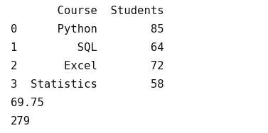
Pandas is widely used for working with tabular data. A DataFrame stores data in rows and columns and makes filtering, grouping, aggregation, cleaning, and transformation straightforward.

5.2 Simple Data Cleaning Example
df["Course"] = df["Course"].str.strip().str.title()
df = df.dropna(subset=["Students"])
df = df[df["Students"] > 0]
The example removes extra spaces and fixes capitalization in the Course column, drops rows where Students is missing, and keeps only rows with a positive student count. In a real project, the cleaning rule should depend on the business context, because deleting rows can also remove useful information.

6. Data Visualization Fundamentals
Visualization helps analysts show patterns and comparisons quickly. The right chart type depends on the question being answered.
Chart | Suitable Use | Example
Bar chart | Compare categories | Students enrolled per course
Line chart | Show trends over time | Daily website visitors
Histogram | Show distribution of numbers | Exam score distribution
Scatter plot | Explore relationship between two variables | Study hours vs marks
Box plot | Compare spread and spot outliers | Delivery time by city

6.1 Example Visualization Code
import matplotlib.pyplot as plt
courses = ["Python", "SQL", "Excel", "Statistics"]
students = [85, 64, 72, 58]
plt.bar(courses, students)
plt.xlabel("Course")
plt.ylabel("Students")
plt.title("Students Enrolled per Course")
plt.show()

Output=
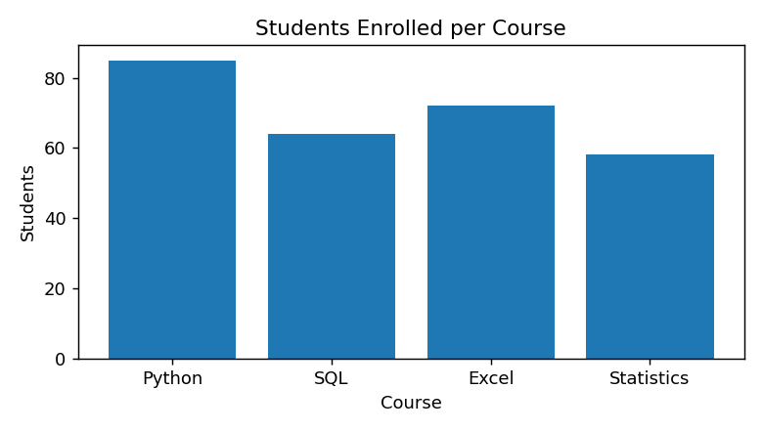

7. Industry Best Practices
- Use clear, meaningful names for variables and columns.
- Write modular code and avoid repeating the same logic.
- Add comments where they make the code easier to follow.
- Validate and check the data before starting the analysis.
- Keep raw data untouched and store cleaned data separately.
- Document assumptions, transformations, and key decisions.
- Make workflows reproducible and note the package and environment versions used.
- Pick charts that deliver the intended message clearly.
- Avoid misleading axes, unsupported conclusions, and unnecessary decoration in charts.
- Protect confidential and personally identifiable information.
- Never treat correlation as proof of causation.
- Be honest about limitations and uncertainty in the results.

7.1 Reproducibility
A reproducible analysis lets another analyst follow and repeat the work and arrive at the same results. This is supported by well-organized folders, documented steps, consistent code, versioned input data, and clearly stated assumptions.

7.2 Responsible Data Analysis
Analysts should keep data privacy, fairness, data quality, and sampling limitations in mind, and watch for interpretations that could mislead. Every conclusion should be backed by the available evidence.

8. Practical Fundamentals Assignment
This mini-assignment applies the Task 1 fundamentals to a small sample dataset.

8.1 Sample Dataset
Student | Branch | Study Hours | Marks
P | CSE | 2 | 54
Q | CSE | 4 | 66
R | ECE | 3 | 70
S | CSE | 6 | 80
T | ECE | 8 | 92

8.2 Questions and Answers
- What is the average Marks? Answer: (54 + 66 + 70 + 80 + 92) / 5 = 362 / 5 = 72.4.
- What is the median Marks? Answer: After sorting, 54, 66, 70, 80, 92; therefore the median is 70.
- Which branches appear in the sample? Answer: CSE and ECE.
- Which student scored the lowest Marks? Answer: Student P, with 54 marks.
- What is one useful insight? Answer: ECE students have a higher average (81.0) than CSE students (about 66.7), and Study Hours and Marks show a strong positive correlation (about 0.96). However, with only five records this is not enough to establish causation.

8.3 Python Solution
import pandas as pd
df = pd.DataFrame({
"Student": ["P", "Q", "R", "S", "T"],
"Branch": ["CSE", "CSE", "ECE", "CSE", "ECE"],
"Study_Hours": [2, 4, 3, 6, 8],
"Marks": [54, 66, 70, 80, 92]
})
print("Average marks:", df["Marks"].mean())
print("Median marks:", df["Marks"].median())
print("Lowest marks:", df["Marks"].min())
print("Correlation:", round(df["Study_Hours"].corr(df["Marks"]), 2))
print(df.groupby("Branch")["Marks"].mean())

Output=
Average marks: 72.4
Median marks: 70.0
Lowest marks: 54
Correlation: 0.96
Branch
CSE 66.666667
ECE 81.000000
Name: Marks, dtype: float64

9. Key Learnings
- Data Science brings together programming, statistics, analytical thinking, and domain knowledge.
- Python gives a practical and beginner-friendly base for data analysis.
- Statistics helps summarize data and explain variation and relationships.
- Identifying data types correctly leads to more accurate analysis.
- Cleaning data is a necessary step before drawing any conclusions.

